FOR IMMEDIATE RELEASE
03/08/2021
DANVERS HISTORICAL SOCIETY | PRESS CONTACTS
Web: www.DanversHistory.org | Laura Cilley
Facebook: @danvershistory | Nora Whouley
Instagram: #danvershistory | dhs@danvershistory.org
Twitter: @DhsSociety | (978) 777-1666

Danvers, MA - Danvers Historical Society announces the Anne L. Page Scholarship
The Anne L. Page Scholarship is administered annually by the Danvers Historical Society and funded by its members. The scholarship award, in 2021, is $200.
This scholarship honors Anne L. Page, who opened the first kindergarten in Essex County at the Jeremiah Page House in Danvers Square. Around 1850 she opened a school for very young children between the ages of 3 to 6. She believed Plato's words that the “. . . power of children's love of play should be used in education”, and in Froebel’s philosophy of creating fun ways to learn. Anne, along with Elizabeth Peabody and Mary Mann, founded the American Froebel Union, to advance early childhood education.
This opportunity is available to a Danvers High School senior who has been accepted into a post-secondary education program that offers a certification training and/or a degree. The candidate must have exhibited consistent participation in one or more of the following programs: Danvers High School Life Skills Program, The Danvers Best Buddies Chapter, Unified Basketball, Northeast ARC Friends of Special Olympics-Danvers Track & Field, DECA, and Student Assistantship Program.
To apply for the Anne L. Page scholarship, create a Going Merry account, and search under "Local Scholarships". Direct link to apply: https://app.goingmerry.com/awards/9779 Contact the Danvers High School Guidance Department with further questions.
###
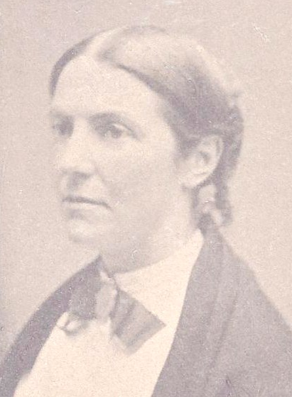
Anne Lemist Page: Educator, Abolitionist, and Suffragette

