**FOR IMMEDIATE RELEASE**

**May 13, 2020**

|  |  |
| --- | --- |
| **DANVERS HISTORICAL SOCIETY** | **PRESS CONTACTS** |
| Web: www.DanversHistory.org | Laura Cilley |
| Facebook: @danvershistory | Nora Whouley |
| Instagram: @danvershistoricalsociety | dhs@danvershistory.org |
| Twitter: @DhsSociety | (978) 777-1666 |
|  |  |

**Danvers Historical Society Celebrates 250th Anniversary of Local Woman’s**

**Tea Protest Ahead of Revolutionary War**

**Danvers, MA**— This May marks the 250th anniversary of Danvers’ Tea Party on the Roof hosted by Sarah Page in 1770, an event the Danvers Historical Society will be recognizing at their historic property, the Jeremiah Page House, and celebrating virtually on their social media channels.

Danvers History Director of Operations Laura Cilley commented, “Even with the temporary closure to the public of our historic buildings, we are still celebrating Tea & History, and the independent spirit of this historic Danvers resident, Sarah Page, and her moment of protest captured in ‘The Gambrel Roof,’ by Beverly poet Lucy Larcom.”

Both the poem and local history recount the actions of Sarah Page and her famous protest of her husband, Jeremiah’s, prohibition to drink British tea within his house. Rather than forgo her modest pleasure, the story goes that she decided to hold her tea party atop the gambrel roof of their home.

Local historian Dan Gagnon, a member of the Danvers Alarm list and the Society, noted in his blog Specters of Salem Village, that “the people of Danvers played an important roles in the years leading up to the Revolution” as vocal participants in the preparations leading to revolt against British tyranny. Danvers History’s celebration captures that era in a virtual and family-friendly event set for May 20.

The Danvers Historical Society will be celebrating virtually this year, with a Facebook Live event on Wednesday, May 20 at 2pm. The public is invited to logon to the Facebook page @DanversHistoricalSociety for a re-enactment and discussion of the history surrounding Sarah Page’s famous protest. The event will feature Lisa Steigerwalt, chair of the DHS Tea and History program, Amy Driscoll, a dedicated Society volunteer, and Sheila Cooke-Kayser, Education Chair, who will hold a tea party at the Page House. Nora Whouley, assistant communications director for DHS, will produce the event.

The Danvers Historical Society invites the public to dress in their best teatime attire and raise a cup in honor of Sarah Page. The Society welcomes virtual participants, especially families and residents excited about history, to post pictures of their own teatime on our Facebook @Danvershistory and Instagram @DanversHistoricalSociety pages. More details on the May 20 Facebook Live event at 2pm as well as a tea-themed word search for children are available at [www.DanversHistory.org](http://www.DanversHistory.org).

###

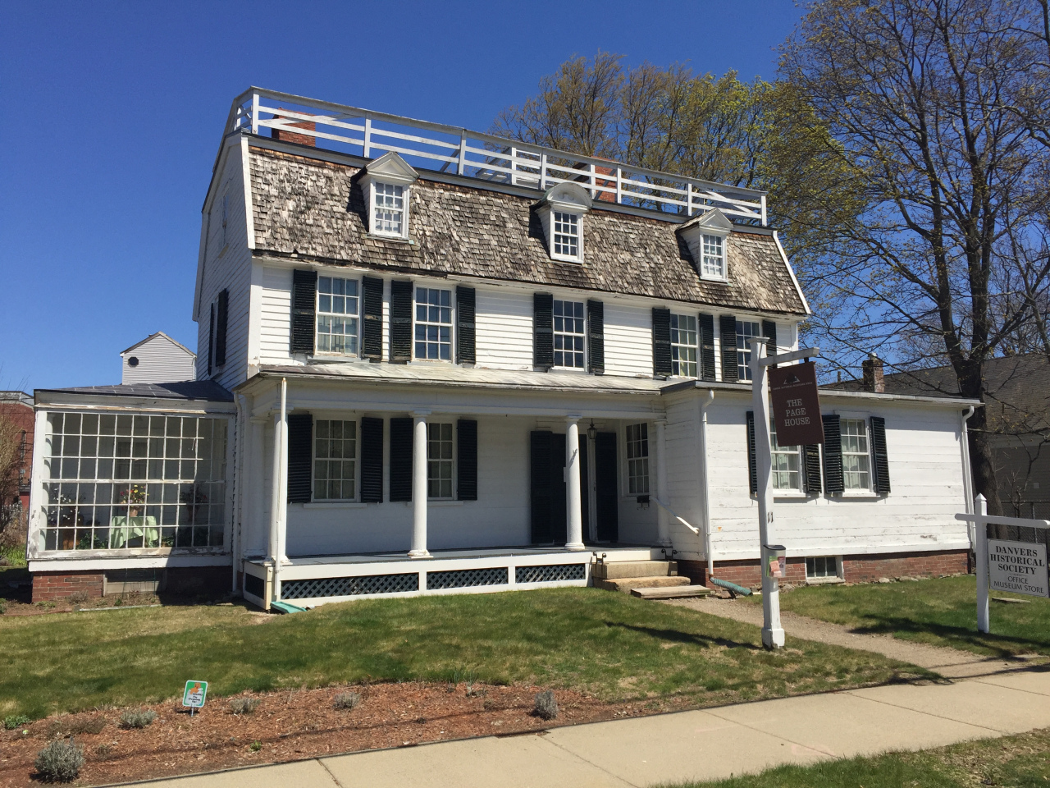

The Jeremiah Page House, Page Street, Danvers, MA.

Photo: Dan Gagnon.